Abstract— We have developed and designed an autonomous firefighter robot to recognize and open doors using a robotic arm. It moves using tracks and two motors. It is identified using an infrared sensor, an ultrasonic sensor, a position camera and a Logitech camera. It is also equipped with a 5-axis robotic arm, modeled and printed in 3D. We have developed a serial communication between the Arduino mega card used to control the mechanical components and the Nvidia Jetson nano JN30D card used in order to simultaneously give orders to the Arduino card and control our AI.
ROBOT Pompier Autonomous
Oumnia Bhikir, and Guillaume Rio

Index Terms— Autonomous robot, robotic arm, infrared sensor, position camera, artificial intelligence, Nvidia Jetson Nano, Arduino, 3D modeling, 3d print,

INTRODUCTION
We talk a lot about the evolution of robotics in the service of medicine and it's true that start-ups are going in this direction. But we talk less about these robots that help people avoid danger while doing their job.
When a firefighter arrives at a fire scene, he must enter the building, explore it and act. It faces many risks, starting with smoke explosions and in this sense, we thought of creating the firefighter robot, inspired by colossus [1], the firefighter robot built by shark robotics, main intervening in the fire of Notre-Dame de Paris [2], a revolution for the fire soldiers who will be able to let the robot open the door, penetrate first, probe the risk zone before knowing if they can intervene without putting their lives in danger.
Pompier is a small robot of 2 kg, measuring 40 cm in height placed on a metal frame (fig 1) equipped with a pair of tracks, able to orient itself in space avoiding any obstacles located at a maximum of 2m thanks to a camera [3], and a multitude of sensors, we can quote the ultrasonic and laser sensor, controlled by an Arduino mega and an Nvidia Jetson nano.
The robot has an arm with 5 degrees of freedom; base-waist-elbow-clamp, modeled on Fusion 360 [4] and printed in PETG on Prusa print [5].
The article is organized as follows, section 2 provides the arm design including construction details and electronic mounting of the robotic arm, while the section 3 gait the movement strategy using DC motors, distance sensor and movement strategy

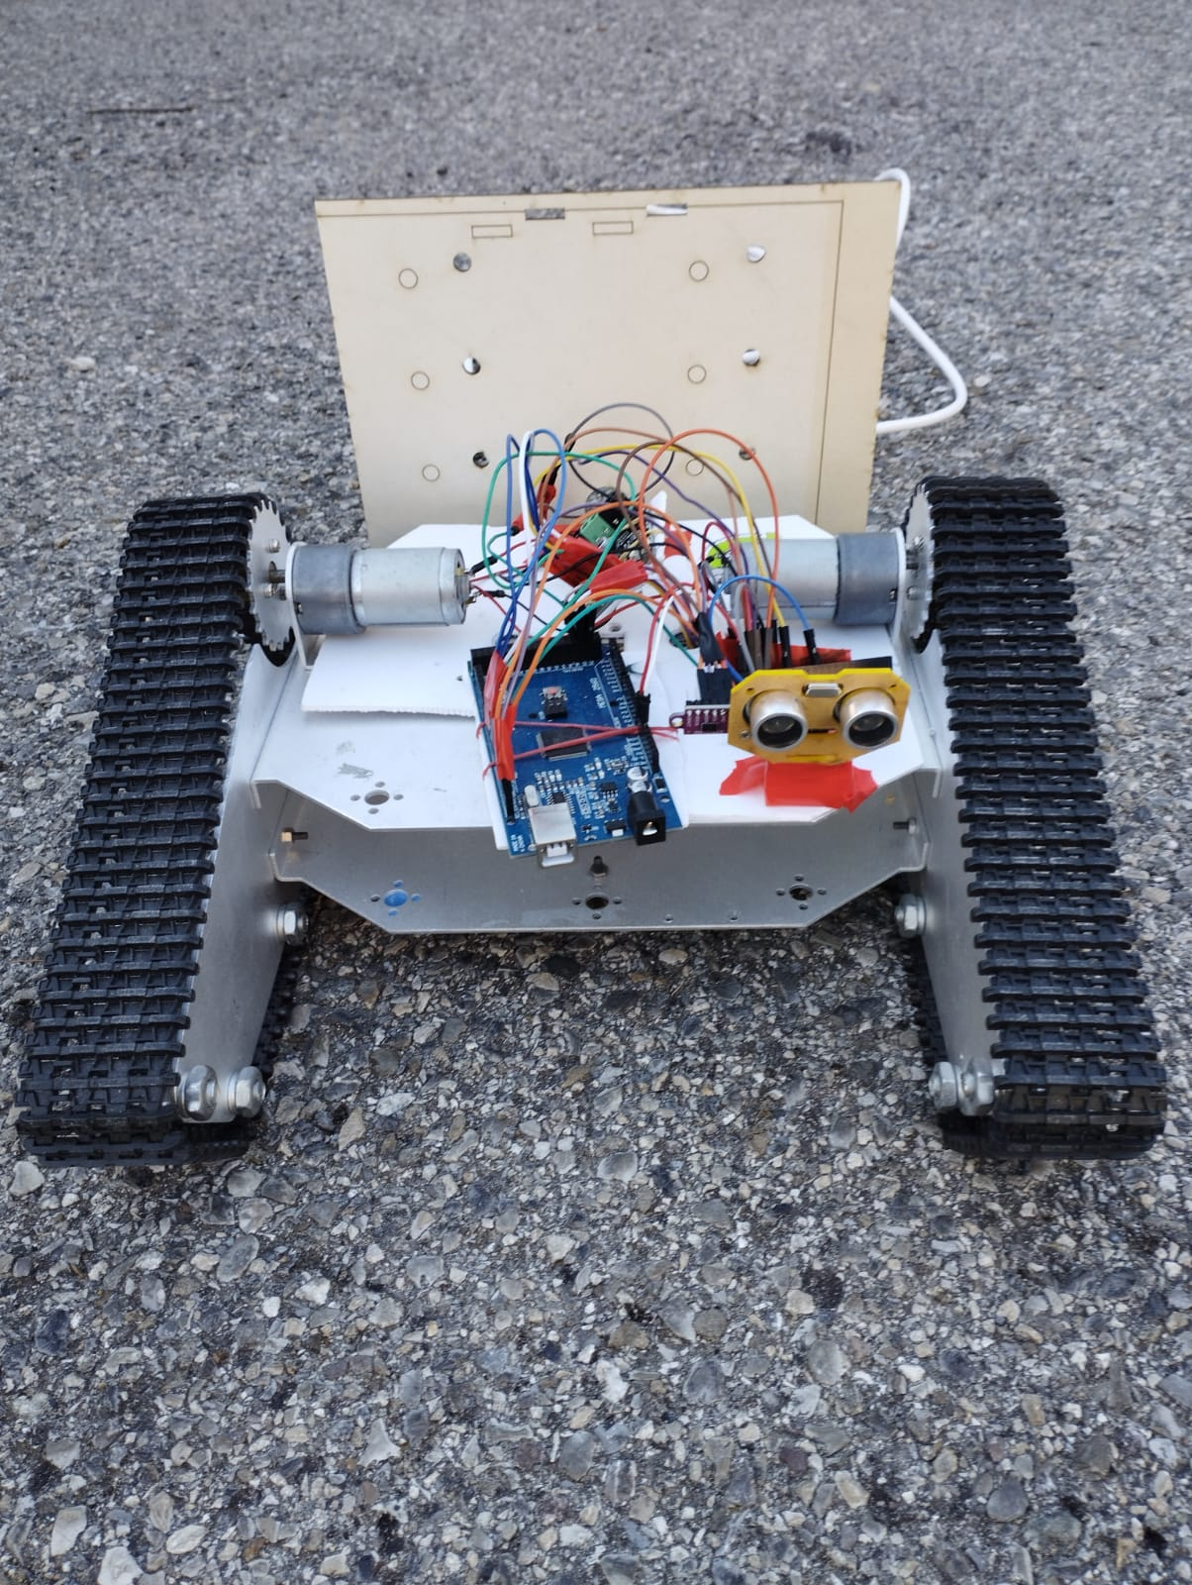
Fig. 1. Metal frame containing the sensors necessary for movement.

Robot arm

Hardware design
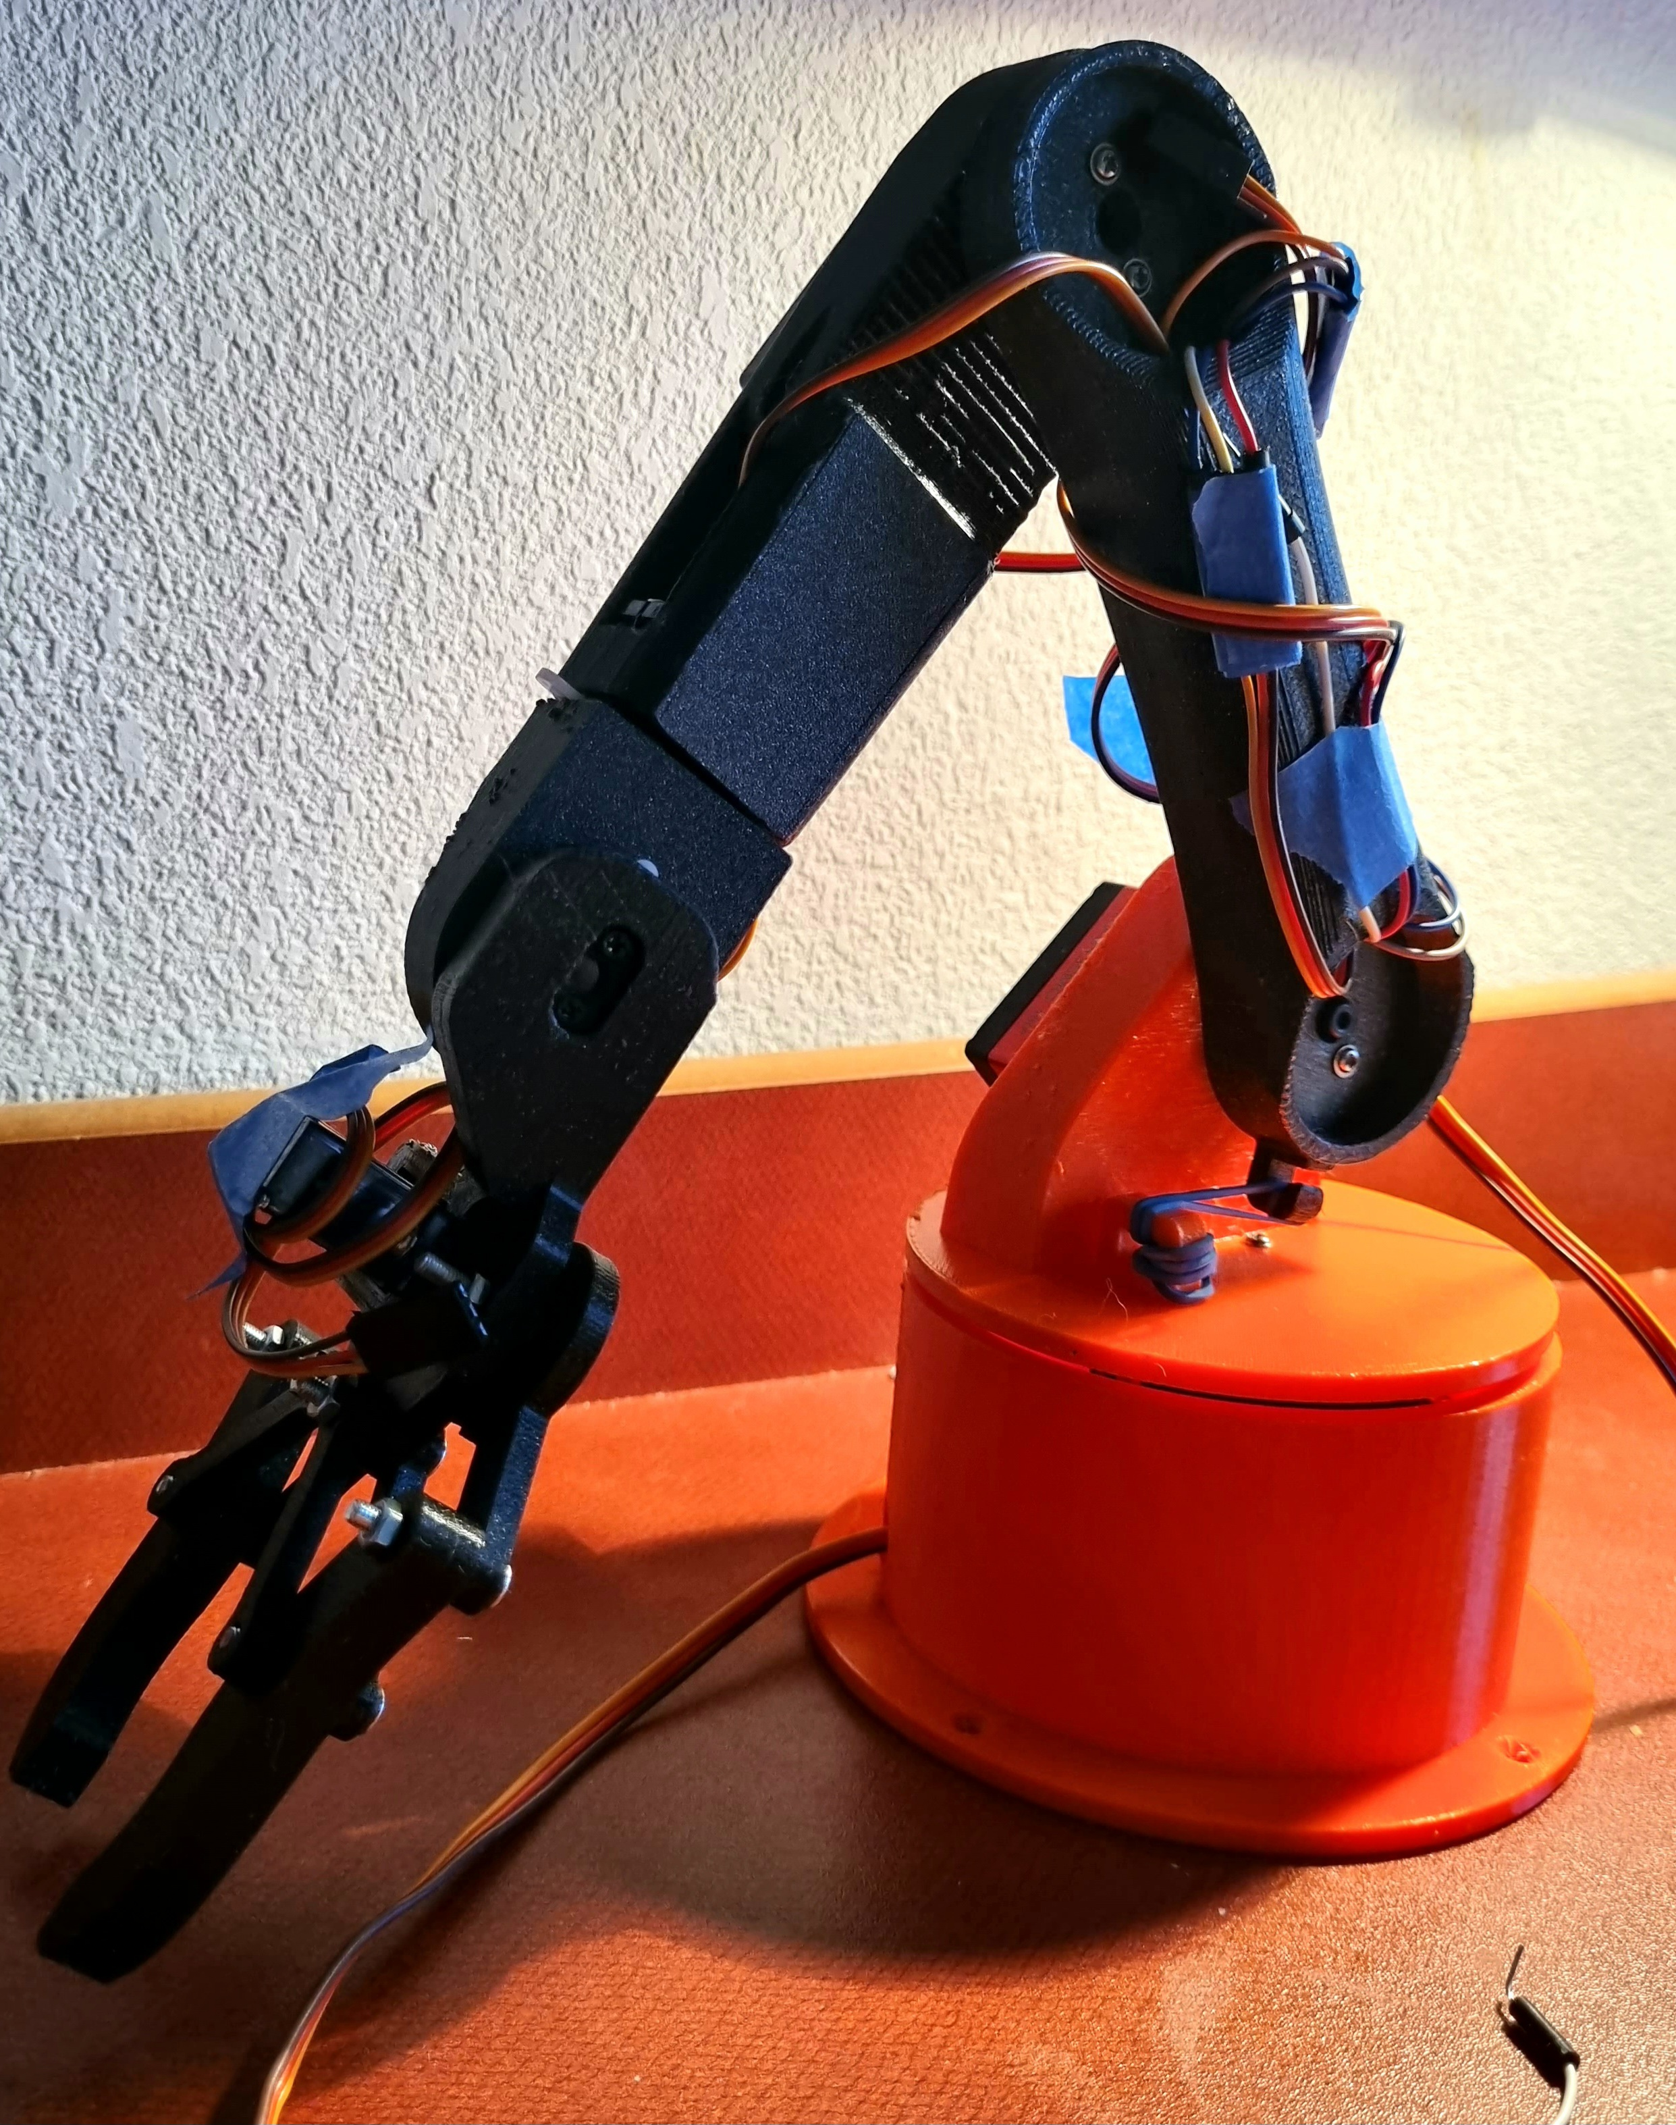
Fig. 2. Robot arms, mainly composed of the base, waist, elbow, and gripper allowing to open a door.

To begin with, we designed the robot arm using Fusion 360 modeling software (fig 2). The base is attached to the rest of the body with 4 holes, it supports the 1st servo motor allowing a rotation of 180° around the Z axis using the screws included in its package, then on the output of the servo we secured a round horn a bolt. On the top we placed the upper part, secured with two screws, where the second servo motors will hang on. Here again they are secured to each other using the bolt on the output.
We include an elastic at the shoulder axis to give some help to the servo, because this one carries the whole weight of the rest of the arm when it returns to its starting position...
In the same way we gathered the rest of the arm. As for the gripper mechanism, we used one that was already modeled on Grabcad [6].
Finally, we attached the gripper mechanism into the last servo and the arm was nearly completed.

Basic arm control
For the first 3 axis, the waist, the shoulder, and the elbow, we used the DS3225 25Kg, manually operated with a potentiometer. The servomotor and the potentiometer are connected to the Arduino as two different circuits.
The potentiometer connects to PIN 5V, GND and analog. While the servo motor connects to the GND PIN, PWM and is linked on the breadboard to an external power supply, then with a DC-DC converter [7] we obtain the necessary 6V.
For the wrist roll and wrist pitch, as well as the gripper we used the smaller SG90 servos.
Each servomotor is controlled with a potentiometer, the code used is accessible directly from the IDE program Arduino, under the name of Knob in the example book, the code uses the map function which makes it possible to scale the potentiometer value to change from 0 to 1023 (analog) to 0 to 180 (degrees).

Autonomous arm control

Motion Calcul
In the case of the robotic arm, we want to be able to automatically position the 3-segment arm only from the coordinates of the P(x,0) point representing the coordinates of the handle.
The principles of geometry and trigonometry must be used to calculate angles of motion. First, it is necessary to know the lengths of each arm segment, the shoulder and elbow, and the coordinates of the end of the arm, also known as the “pointer”. Then, using the Pythagorean theorem combined with Al-Kashi, we can determine the distance between the attachment point of the first segment and the pointer. By applying the cosine law, we calculate the angle between the first segment and the reference axis. Similarly, using the law of the sinus on the triangles formed by the successive segments, we determine the angles of the other segments of the arm. By combining this information, we obtain from the only position of P, the handle, the lengths r1,r2,r3 of the segments and fixing a coefficient k, of margin of error, it is possible to know the 3 angles of the servomotors having the axis located in
P1, P2 and P3 allowing automatic positioning of the motorized arm with 3 segments by the single
knowledge of the position of the object to be gripped with the arm clamp.
In the case of an arduino application, the question that arises is to decide on which "side" it is the wisest to code the described calculation sequence.
It thus seems more relevant to code this sequence on the Processing side, which will make it easier to perform the calculations involving the functions acos() and atan(), although the Arduino can perform these calculations with less precision.

Arm control
The code is composed of two main functions.
Movearm, responsible for the movement of the arm where we put the coordinates of the point to reach as a parameter then we calculate, the angle of the shoulder and the elbow.
Moveservo to adjust the measurements, sincere the arduino has a margin of error.
The measurements are then transformed from radians to degrees.

Vision

Technical needs
Our robot must recognize doors and be able to reach them. Initially, we chose to use a Logitech camera to complete this task. We are aware that in a real situation we will need more versatile sensor but for our prototype we will focus on this choice. So, we connected the camera to the Nvidia card via USB. We will use Python and the OpenCV library to make our algorithm.
The objective of our algorithm must fill is to obtain an image, analyze it to know if there is a door in front of the robot and determine in which direction the robot must turn to approach the door.

Picture analyze.
First of all, to take a photo we use an OpenCV function, allowing us to recover 30 images per second. Then, we will analyze as quickly as possible one of the images. Our objective during this analysis is to obtain the middle position of the door. So, we will filter our image using different masks and the “bitwise_and” function. We then isolate the vertical lines with the HoughLines function and our algorithm will groups close lines. Finally, we use the function findContours and if we detect a rectangle block of the orange color, we assume that this corresponds to our door.

Door analyze
Once our door is detected, we must find the position of the handle in order to direct the robot arm to the right place. Thus, we will isolate only the door on the image using the “resize” function. On our new image, we will use the “detectAndCompute” function to get the Key Point of the image. Finally, if several Key Points point on the same area, we analyze the shape and if the latter is round, we deduce our handful.

Direction analyze
Our last piece of information to get is the orientation in which the robot must turn to approach the door. To do this, we use two pixel values. The x value of the pixel in the center of the image and the x value of the pixel in the center of the door. By realizing the difference between the two values, we can know if the robot should turn right, turn left or go straight.

Movement

DC Motors
In order to move, the robot is equipped with 2 DC motors, mechanically connected to the tracks. These motors are 7.2V motors, we control them using an H-bridge motor control board. The control board is directly connected to the 7.2V and provides us two PWM pins for each motor. They are used to define the speed and direction of rotation of the motor.

Mouse sensor
When the robot moves, we need to have an approximate position of our robot, so we use a mouse sensor. This camera will observe the ground and when it detects a displacement will notify the direction of displacement in 2D (according to X and Y). We use the ADNS3080.h library [8] which is very powerful and so takes care of all the SPI protocol and allows us to have all the useful values ​​available using one or two methods.
However, in our current solution the camera is too high to be fully used. And so, generates a lot of noise during the measurements.

Distance sensors
Our robot needs to see ahead in order to avoid obstacles. Therefore, we decided to use three distance sensors, an ultrasonic sensor and two laser sensors. These two types of sensors cooperate very well because they have opposite strengths and weaknesses. So, depending on the distance that we measure, we have to trust one of the two types of sensors.
For the ultrasonic sensor, we use the trig and echo pins to measure the time it takes for the ultrasound to return. So we can calculate the distance to the first obstacle. However, in the current state of our robot, the program waits for the ultrasound to come back before executing other actions and so blocking the robot.
For the laser sensor, we use the Adafruit_VL53L0X.h library [8]. This library is very easy to use, we specify the pin of our sensor and by using the method, we obtain the distance in mm measured by the sensor.
We chose to place the two sensors respectively on the right and left of the robot. By obtaining the measurements of the two sensors we can know if the robot is facing a wall, facing right or facing left. So we coded a function so that the robot could stand facing the wall in front of it, if the Nvidia ordered it.

Movement strategy
So, as specified in part 3.D, we know the direction in which the robot must turn for an instant t . So we will rotate the robot more or less quickly according to the number of pixels of the difference made on our image. This method remains imperfect because the number of pixels depends greatly on the distance between the robot and the door.
To limit this problem, we coded a function that starts every 10 seconds and places the robot at a precise distance from the obstacle.
The robot also uses a function to replace itself in front of an obstacle. We use this function before opening the door to be well in front of the entrance.

Distance sensors
The Nvidia Jetson Nano JN30D card is a card design for AI. We use a docker container to run Jupyter on the nvcr.io/nvidia/dli/dli-nano-ai:v2.0.1-r32.6.1 image. Now, the pytorch installation is faulty, which prevents us from doing artificial intelligence. But soon, the problem should be fixed.

Electronic Image
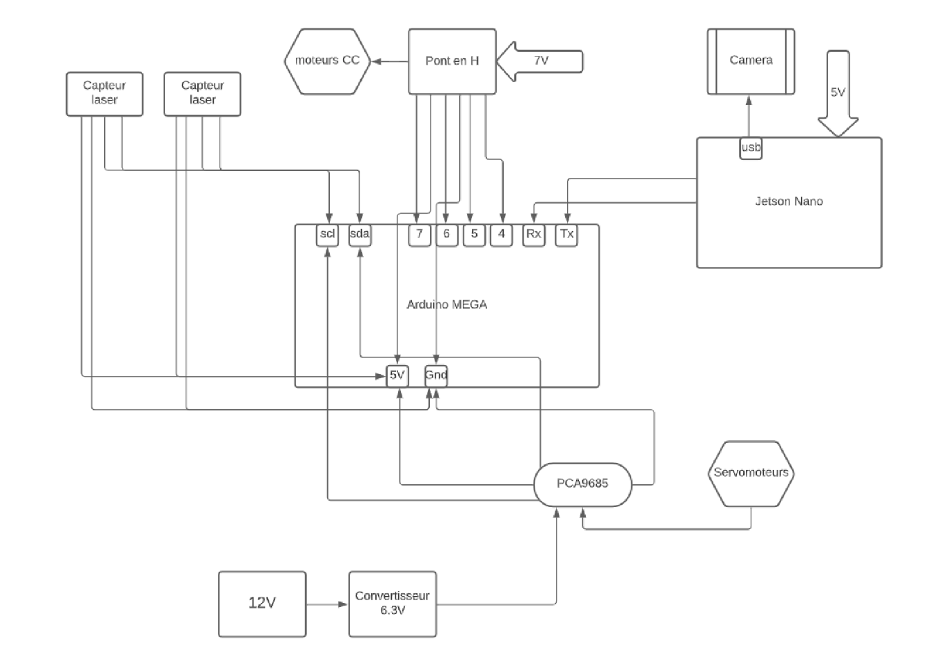
Fig. 3. Electronic diagram of our entire robot.

The Arduino MEGA board (fig 3) represents the control center, its GND is the common ground of all components.
The arrows (fig 3) represent the cables, it connects the Arduino by the RX-TX pins to the Jetson Nano and by the 4-5-6-7 pins to the H-bridge which controls the DC motors and powers the board, among other things.
The SCL and SDA (fig 3) are common to the driver of servomotors and laser sensors. An AC-DC converter converts the mains voltage into the 6.3V required for the proper operation of the 6 arm servomotors.

Communication

UART communication
Our robot has two boards, the Nvidia Jetson nano board and the arduino board. As the Nvidia board is dedicated to strategy, it must send orders to the arduino board so that they are carried out by the robot. To do this we have added a UART communication on the third UART bus of the arduino board and on the single jetson board.
We also added a cable to make the GND on both boards common. This is necessary so that the cards are synchronized so that they have a clear communication without any offset bit.

Communication frame
To be able to understand the information exchanged, we had to define the different frames that the two cards will send to each other. It was decided that the starting character would define the frame. For example, a frame starting with a “1” corresponds to information dedicated to engines.
With this defined system, we were able to code the decoding functions of the frames. So when you want to add a new frame 3 steps are necessary. First, define if the frame type is already existing or if it is new information, modify or add the decoding function, and then test on boundary cases.

Conclusion
This paper describes the design and development of an autonomous firefighter robot capable of moving autonomously avoiding obstacles, detecting its environment with a camera and sensors while positioning itself with a mouse sensor.
Certainly, more studies are needed to improve the robustness of the tested arm and movement fluidity, but the arm can move according to the 5 degrees of freedom and to exert a slight force on a handle modeled on its size which is more than enough.
References

- https://www.shark-robotics.com/colossus
- https://www.numerama.com/tech/920873-les-secrets-de-colossus-le-robot-pompier-qui-a-affronte-lincendie-de-notre-dame-de-paris.html
- https://ardupilot.org/copter/docs/common-mouse-based-optical-flow-sensor-adns3080.html
- https://www.autodesk.fr/products/fusion-360
- https://www.prusa3d.com/fr/produit/kit-de-l-original-prusa-i3-mk3s-3
- https://grabcad.com/
- https://2betrading.com/accueil/2497-module-convertisseur-dc-dc-12a.html
- RCmags,“ ADNS3080.h library”, https://github.com/RCmags/ADNS3080
- evaherrada, “Adafruit_VL53L0X library”, https://github.com/adafruit/Adafruit_VL53L0X

O. BHIKIR, studied PEIPC at Polytech Grenoble, currently studying engineering at Polytech Nice Sophia in the Robotics department

G. RIO, hold a DUT in computer science and a DU in robotics, currently studying engineering at Polytech Nice Sophia in the Robotics Autonomous department

 O. BHIKIR, student at Université Côte d'Azur, Polytech' Nice Sophia, Department of Robotics, 930 Rte des Colles, 06410 Biot (e-mail: oumnia.bhikir@etu.univ-cotedazur.fr). G. RIO, student at Université Côte d'Azur, Polytech' Nice Sophia, Department of Robotics, 930 Rte des Colles, 06410 Biot (e-mail: guillaume.rio@etu.univ-cotedazur.fr).

